1.1

SELECT CustomerID, CompanyName, Address, City, Region, PostalCode, Country

FROM Customers

WHERE City IN('London', 'Paris');

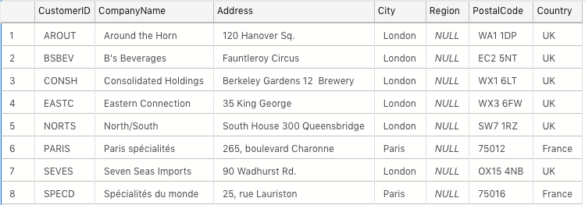

1.2

SELECT ProductName

FROM Products

WHERE QuantityPerUnit LIKE '%bottles%';

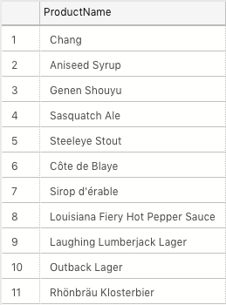

1.3

SELECT Products.ProductName, Suppliers.CompanyName, Suppliers.Country

FROM Products

INNER JOIN Suppliers ON Products.SupplierID = Suppliers.SupplierID

WHERE QuantityPerUnit LIKE '%bottles%';

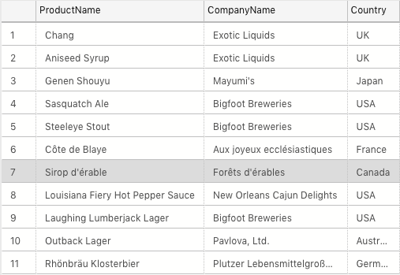

1.4

SELECT COUNT(ProductName) AS 'No. Of Products', Products.CategoryID, Categories.CategoryName

FROM Products

INNER JOIN Categories ON Products.CategoryID = Categories.CategoryID

GROUP BY Products.CategoryID, Categories.CategoryName

ORDER BY [No. Of Products] DESC;

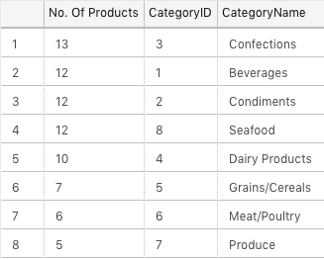

1.5

SELECT CONCAT(TitleOfCourtesy, FirstName, LastName) AS 'Employee', City

FROM Employees

WHERE Country = 'UK'

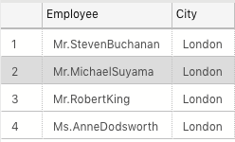

1.6

SELECT Region.RegionDescription, FORMAT(SUM([Order Details].Quantity \* [Order Details].UnitPrice), 'C', 'eng-us') AS 'sales'

FROM Territories

INNER JOIN Region ON Territories.RegionID = Region. RegionID

INNER JOIN EmployeeTerritories ON Territories.TerritoryID = EmployeeTerritories.TerritoryID

INNER JOIN Orders ON EmployeeTerritories.EmployeeID = Orders.EmployeeID

INNER JOIN [Order Details] ON Orders.OrderID = [Order Details].[OrderID]

GROUP BY Region.RegionDescription

HAVING SUM([Order Details].Quantity \* [Order Details].UnitPrice) > 1000000

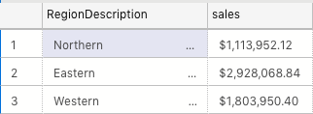

1.7

SELECT COUNT(\*)

FROM orders

WHERE Freight > 100 AND ShipCountry IN('USA', 'UK');



1.8

SELECT TOP 1 OrderID, Discount

FROM [Order Details]

ORDER BY Discount DESC



2.1

CREATE TABLE engineering29

(

Title VARCHAR(5) NOT NULL,

FirstName VARCHAR(50) NOT NULL,

LastName VARCHAR(50) NOT NULL,

UniversityAttended VARCHAR (100),

CourseTaken VARCHAR(50),

MarkAcheived VARCHAR(5),

YearGraduated INT

)

2.2

);

INSERT INTO engineering29

(

Title, FirstName, LastName, UniversityAttended, CourseTaken, MarkAcheived, YearGraduated

)

VALUES

(

'Mr', 'Philip', 'Faboya', 'University of Surrey', 'Chemical Engineering', '2:2', 2016

);

INSERT INTO engineering29

(

Title, FirstName, LastName, UniversityAttended, CourseTaken, MarkAcheived, YearGraduated

)

VALUES

(

'Mr', 'Benjamin', 'Owusu-Sekyere', 'London South Bank', 'Business with Finance', NULL, 2018

);

INSERT INTO engineering29

(

Title, FirstName, LastName, UniversityAttended, CourseTaken, MarkAcheived, YearGraduated

)

VALUES

(

'Miss', 'Moura', 'Akkari', 'Queen Mary', 'MSc Bioinformatics', 'Merit', 2018

);

INSERT INTO engineering29

(

Title, FirstName, LastName, UniversityAttended, CourseTaken, MarkAcheived, YearGraduated

)

VALUES

(

'Mr', 'arthur', 'Hussey', 'University of Oxford', 'MEng Materials', '1st', 2018

);

INSERT INTO engineering29

(

Title, FirstName, LastName, UniversityAttended, CourseTaken, MarkAcheived, YearGraduated

)

VALUES

(

'Mr', 'Taher', 'Khan', 'London South Bank', 'Information Technology', '1st', 2017

);

INSERT INTO engineering29

(

Title, FirstName, LastName, UniversityAttended, CourseTaken, MarkAcheived, YearGraduated

)

VALUES

(

'Mr', 'Aaron', 'Leslie', 'Queen Mary', 'Mathe,atics', NULL, 2017

);

INSERT INTO engineering29

(

Title, FirstName, LastName, UniversityAttended, CourseTaken, MarkAcheived, YearGraduated

)

VALUES

(

'Mr', 'Christopher', 'Baker', 'University College London', 'Digital Humanities', 'Merit', 2018

);

INSERT INTO engineering29

(

Title, FirstName, LastName, UniversityAttended, CourseTaken, MarkAcheived, YearGraduated

)

VALUES

(

'Mr', 'Robert', 'Teal', 'Leeds Beckett', 'MSc Sound & Music for Interactive Games', NULL, 2018

);

INSERT INTO engineering29

(

Title, FirstName, LastName, UniversityAttended, CourseTaken, MarkAcheived, YearGraduated

)

VALUES

(

'Mr', 'James', 'Bachen', 'Bournemouth University', 'Music and Audio technology', NULL, 2018

);

INSERT INTO engineering29

(

Title, FirstName, LastName, UniversityAttended, CourseTaken, MarkAcheived, YearGraduated

)

VALUES

(

'Mr', 'Seb', 'Van Woerkom', 'University of Kent', 'American and English Literature & History of Art', NULL, 2018

);

INSERT INTO engineering29

(

Title, FirstName, LastName, UniversityAttended, CourseTaken, MarkAcheived, YearGraduated

)

VALUES

(

'Miss', 'Qamar', 'Aden', 'University of Portsmorth', 'Petroleum Engineering', NULL, 2018

);

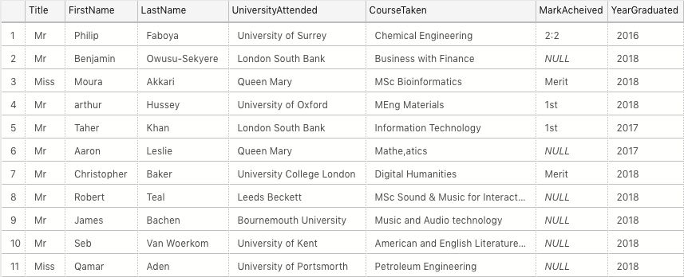

3.1

SELECT EmployeeID, FirstName, LastName, ReportsTo

FROM Employees

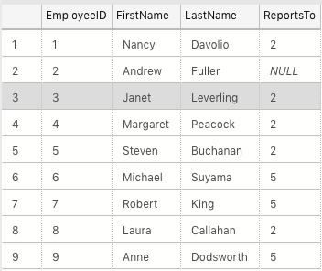

3.2

SELECT SUM([Order Details].UnitPrice \* Quantity) AS 'Sale', Suppliers.CompanyName

FROM [Order Details]

INNER JOIN Products ON [Order Details].[ProductID] = Products.ProductID

INNER JOIN Suppliers ON Products.SupplierID = Suppliers.SupplierID

GROUP BY Suppliers.CompanyName

HAVING SUM([Order Details].UnitPrice \* Quantity) > 10000

ORDER BY SUM([Order Details].UnitPrice \* Quantity) DESC;



3.3

SELECT TOP 10 Customers.CompanyName, [Order Details].Quantity \* [Order Details].UnitPrice AS 'Value', Orders.ShippedDate

FROM Customers

INNER JOIN Orders ON Customers.CustomerID = Orders.CustomerID

INNER JOIN [Order Details] ON Orders.OrderID = [Order Details].OrderID

WHERE orders.ShippedDate > '1997-12-31'

ORDER BY [Order Details].Quantity \* [Order Details].UnitPrice DESC;

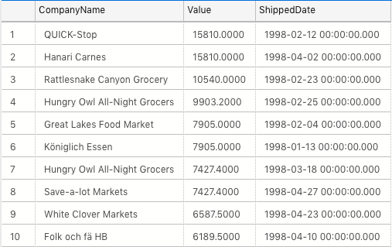

3.4